# MiniVIE Demonstration Setup Manual

This manual goes through the process necessary to download the MiniVIE open-source project code package and run the MiniVIE Demonstration completely.

Contents

MiniVIE Demonstration Setup Manual 1

Section I: Setting up the code Repository 2

Importing MATLAB Code 2

Setting up git 3

Section II: MATLAB First Time Setup 4

Section III: Running the MiniVIE 5

Section IV: Training 10

Section V: Running the MiniVIE Demonstration 15

Appendix A: Setting up Measuring Computing DAQ 24

Appendix B: Setting up Limits and Reversing Joints 25

## Section I: Setting up the code Repository

### Importing MATLAB Code

This section details how to extract code from the internet and import it to MATLAB.

***Note****: While steps 1-21 are specific to the MiniVIE Demonstration, they can be applied to any download of files from the internet imported into MATLAB.*

1. Open up a web browser and navigate to the link: <https://bitbucket.org/rarmiger/minivie>
2. Click the “Download repository” link:

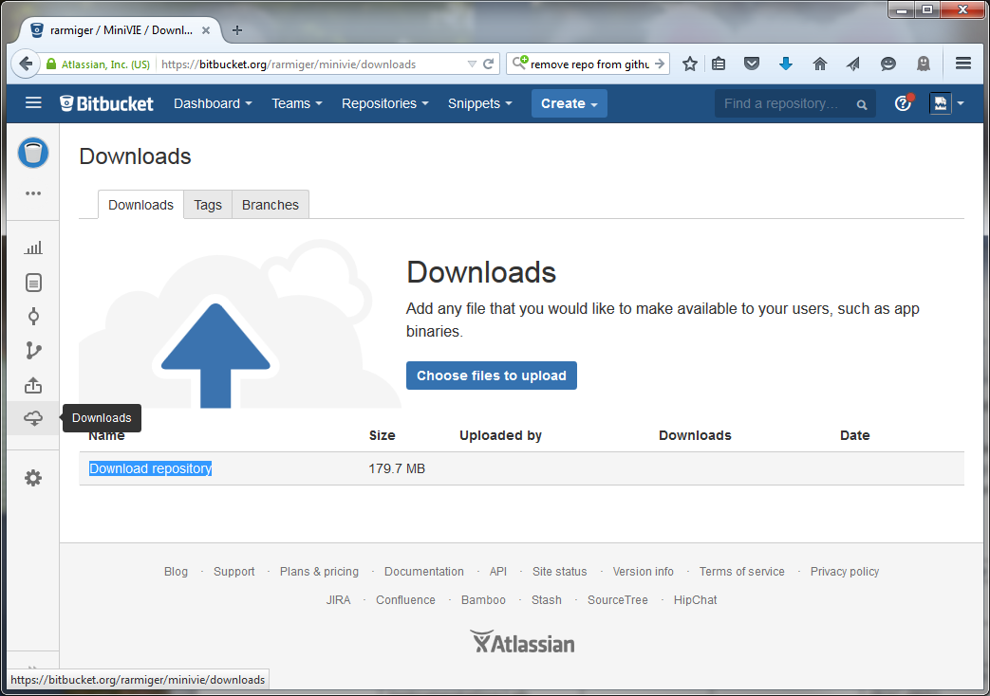

1. Save the file to a folder on your computer (e.g. the *Downloads* folder)
2. Open the folder containing the ZIP file
3. Right-click the ZIP file and select *Extract All…*
4. Select destination “*c:\git”*  and then Extract:

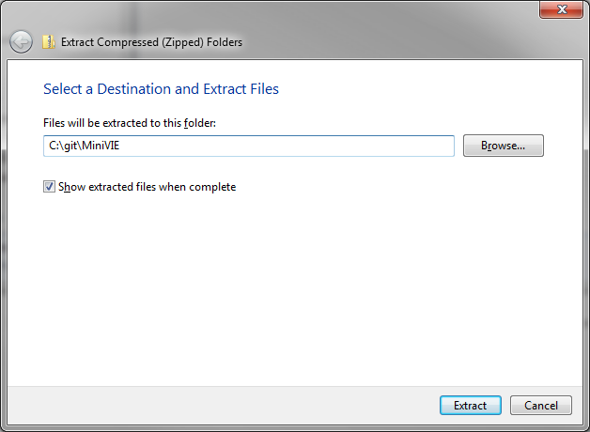

### Setting up git

1. If you are a developer or want to stay current with the latest changes, you can install a *git* tool such as: <https://windows.github.com/>
2. The repository can then be linked to the tool and any changes can be downloaded pulled from the server  
   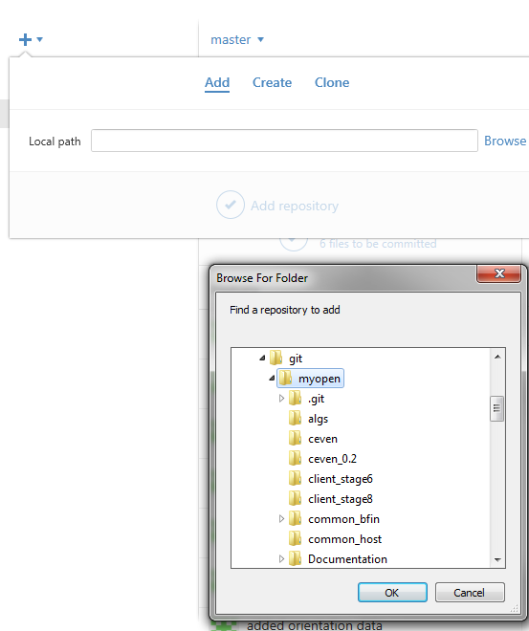
3. GitHub repository manager. The github manager allows you to obtain updates using the ‘Sync’ button in the top-right corner

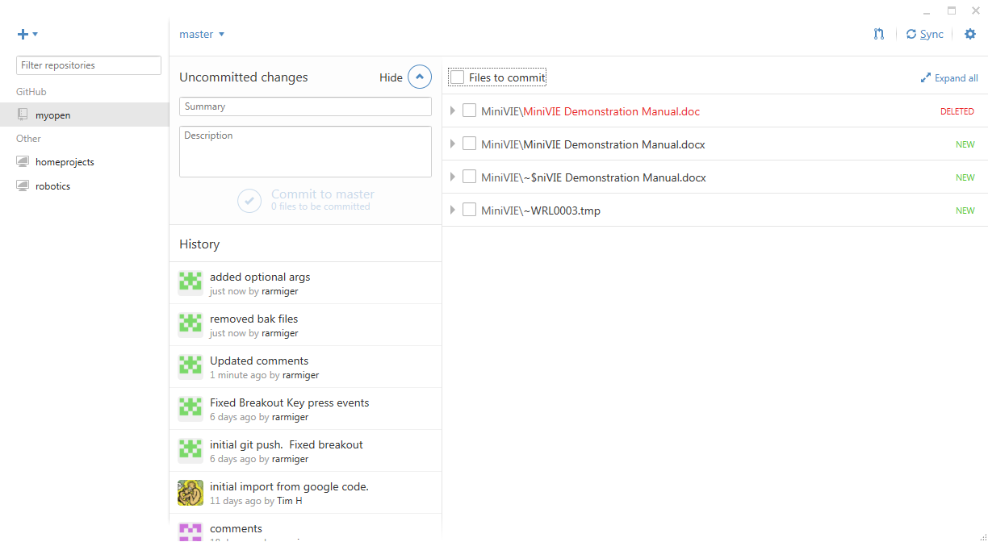

## Section II: MATLAB First Time Setup

1. Open MATLAB
2. Navigate to the *C:\git\ MiniVIE* folder
3. Run the command:  
   >> MiniVIE.createShortcuts

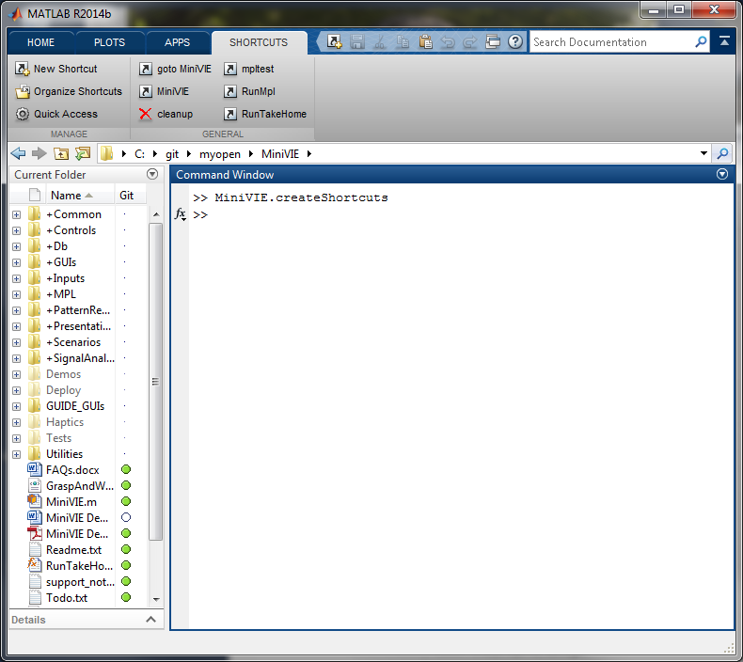

1. This will generate a group of links for quick access to MiniVIE tools

## Section III: Running the MiniVIE

1. Open MATLAB
2. From the shortcuts menu select ‘MiniVIE’
3. A window titled *MiniVIE Configuration Utility* will open with the settings for the MiniVIE program:

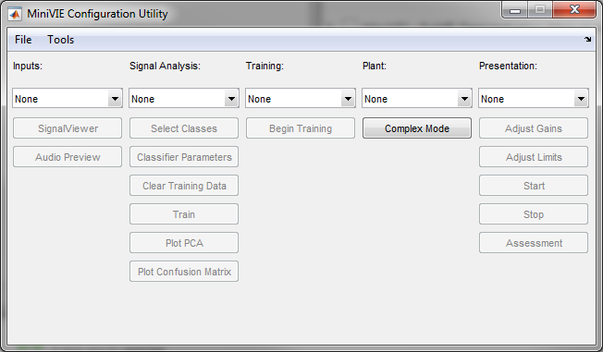

1. In the *Inputs* drop-down menu, select *Signal Simulator:*

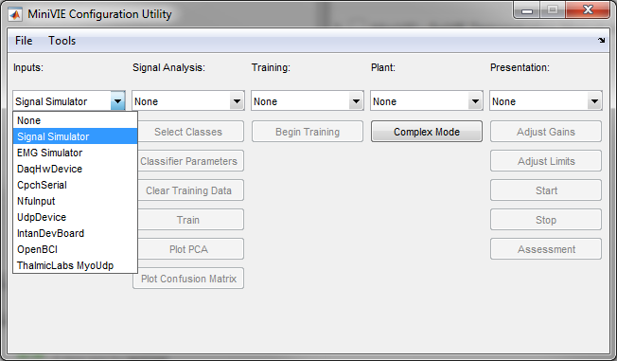

1. A *EMG Simulator* dialogue window should open.
2. While the user is in this selected open window, pressing any of the following keys will cause a number to appear as the current pattern: keys a, s, d, f, q, w, e, r, z, x, c, v.

(Key: a) (Key: v)

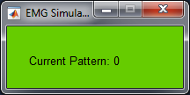 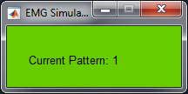 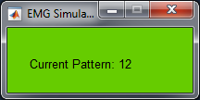

Note: Ensure that the Simulator Window is the ActiveWindow on your systems so that key presses are directed toward MATLAB

1. Under *Signal Analysis*, select *LDA Classifier*:

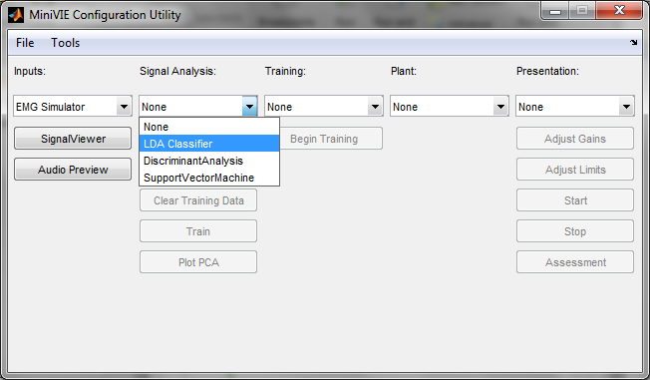

1. Next click on the *Select Classes* button and a new window will open:

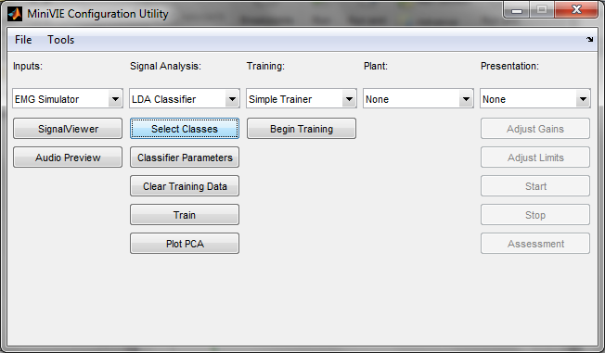

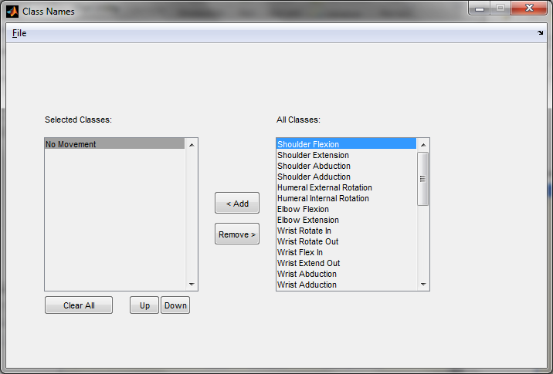

***Note:*** *Each class selected is a movement the arm will perform. Using the EMG Simulator, a maximum of 8 movements can be selected at a time. In addition to the 8 movements, “No Movement” should also always be selected so there is a baseline for each training session.*

1. Select the classes that are to be trained. Then close the window:

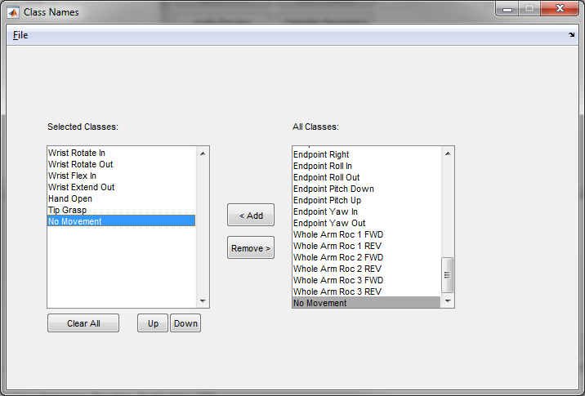

1. Under *Training,* select *Simple Trainer*:

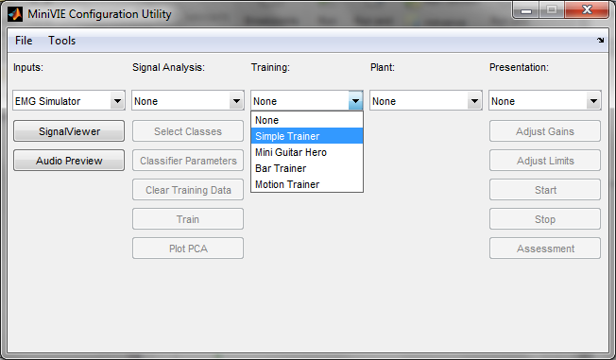

***Note:*** *Do not select any options for Plant or Presentation drop-down menus prior to beginning training.*

1. Select the desired settings for simple training when the dialogue box opens.

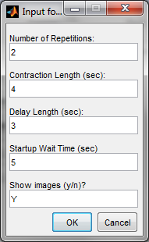

## Section IV: Training

This section goes through step by step of the training process. Before beginning the actual training process, the user should read the entire following section to understand the required actions of the user during the rapid training process.

***Note:*** *Record ahead of time (for future use in the MiniVIE demonstration) which key the user will assign to each movement class.*

1. A window will pop up with a 3 second countdown:

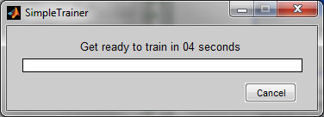

***Note:*** *as soon as the countdown begins, the user must select the EMG Simulator window (window should be maximized and click on this window to highlight it as the selected window). Keep this as the selected open window for the duration of the training process.*

1. The Trainer will then begin training with the first of the 8 selected classes. There will be a period of a few seconds (represented by a red loading bar) allowing for preparation:

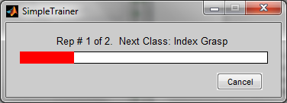

1. During this time, press and hold down one of the designated 8 keyboard keys (a, s, d, f, q, w, e, r) which will later be assigned to the selected class. The *Current Pattern* will change pattern number. Continue to hold down the selected key and **do not release the keyboard key** throughout the next step:

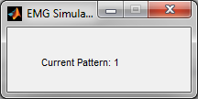

1. The bar will then change from red to green and retreat to the left. During this time, the trainer program is collecting a signal from the selected keyboard key and matching that signal to the command being trained:

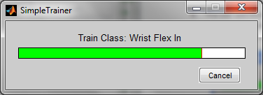

1. When the data is collected, the training will transition to the next class. During the preparation period, switch the keyboard key selected (ie., release the first key chosen, and choose another of the remaining 7 key options). This should be represented by a change in the *Current Pattern* number:

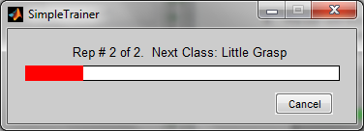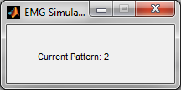

1. Hold down the chosen keyboard key until the training for the current class is complete:

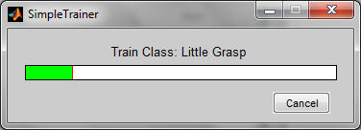

1. Repeat steps 4 - 6 for the remaining classes, except for the “*No Movement”* class.
2. For the training of the “*No Movement”* class, do not press any keyboard key:

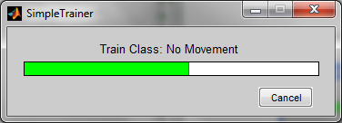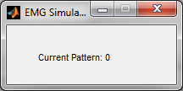

***Note:*** *The reason for not depressing a key during the “No Movement” class is that during the demonstration, the object (the arm for the MiniVIE demonstration) will remain still while it is not receiving signals. Otherwise, the user would have to hold down a key to keep the object still.*

1. Training is now completed:

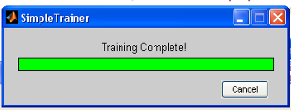

1. When prompted with the window below, save the data gathered in this training session:

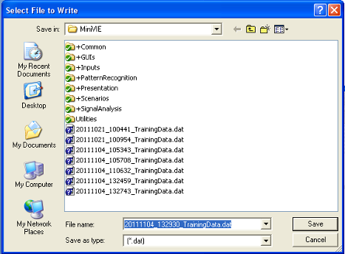

1. Open the MATLAB window. In the MATLAB *Command Window*, the accuracy of the results from the training session is shown. Check the results and if they are not 100% for each command, return to step 1 and perform a new training session:

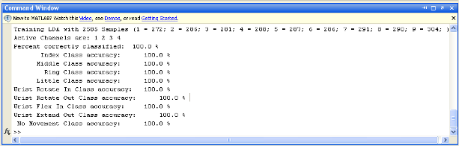

12. Once the user has read the training instructions above, select *Begin Training* in the MiniVIE Configuration Utility window:

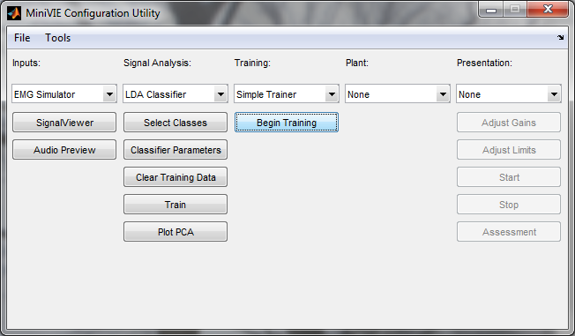

## Section V: Running the MiniVIE Demonstration

This section explains how to run the MiniVIE Demonstration once training is complete.

1. Return to the *MiniVIE Configuration Utility* window, and in the *Presentation* drop-down menu, select *MiniV*. A window with an animated human arm will open:

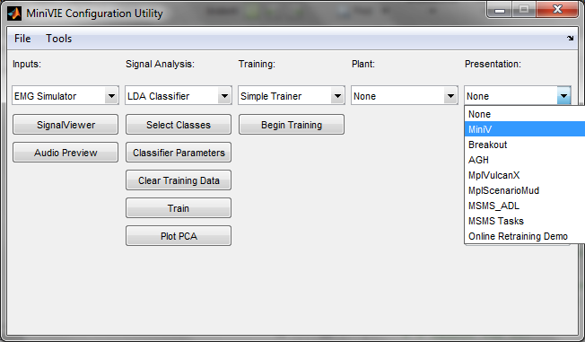

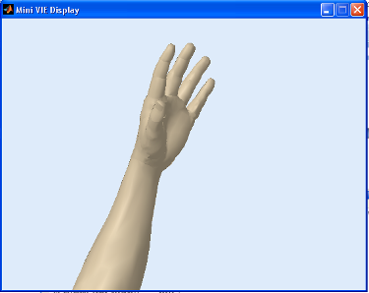

1. Select the *EMG Simulator* window.
2. Press one of the 8 keyboard keys associated with the eight movement classes:

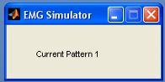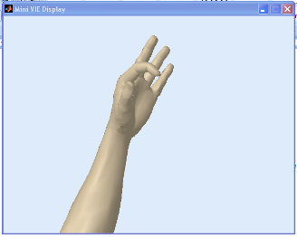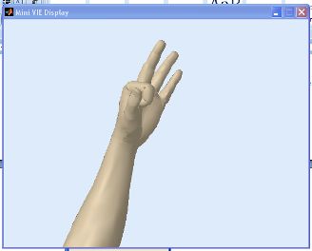

1. Repeat step #3 with each of the remaining movement classes, to verify that the animated arm responds as expected to each of the command.

***Note:*** *In the MATLAB Command Window, the movement class that appears in real-time during the demonstration simulation, reflects the key currently being depressed (which was assigned during the training process to that movement class):*

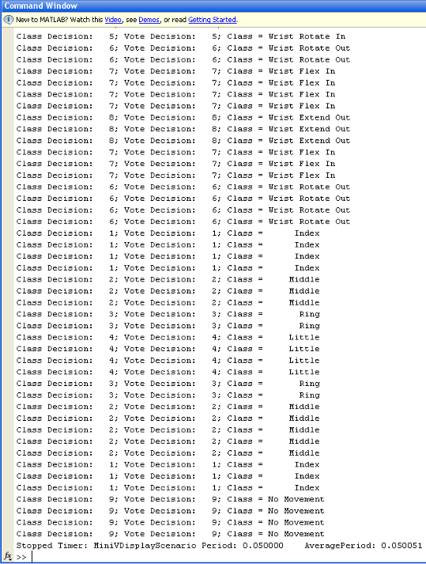

1. To end the demonstration, exit out of the *MiniVIE Display* window.

## Section VI: Running User Assessments

User assessments allow metrics to assess the efficacy of control over a prosthetic limb. There are three main classes of assessment metrics: classifier metrics, evaluative metrics, and functional metrics.

### Classifier Metrics

Upon training the classifier, the MiniVIE immediately reports classification accuracy and a confusion matrix. This value reflects the ability to which data can be predicted by the classifier. This results, however is biased and may be artificially high since it is reclassifying data used to train the classifier. While this value is accessible, it should not be reported as an outcome. A more accurate approach would be to leave out a portion of the training data set for cross-validation and testing. However even these are ‘offline’ metrics since the user has no opportunity to adapt control based on the performance of the arm.

### Evaluative Metrics

Within the MiniVIE, there are two MATLAB based assessments that involve user interaction to achieve desired motions of the virtual system. These assessments differ from offline classification metrics in that the user receives real-time feedback of the current motion prediction, and as such has the capability to modify or shift their control to achieve the correct output.

#### Motion Tester

The objective of the motion tester is to have the user generate an intended motion 10 times. A text based display is generated allowing the user to see the current system output.

To start the Motion Tester:

* Configure and train the MiniVIE with desired motion classes
* Confirm that user is able to control the virtual limb using the Unity Visualization
* Select the ‘Assessment’ Button from the MiniVIE  
  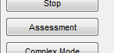
* Select the Motion Tester from the dialog box  
  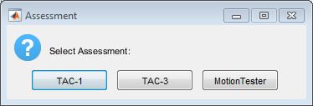
* Press Begin to start the assessment  
  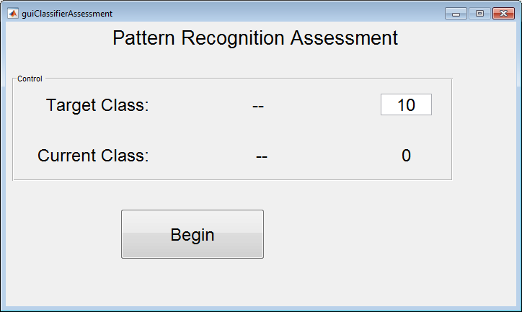
* The user will next be presented with a ‘Target Class’, which is their motion goal. If the users motion matches the goal, a point wil be scored for each correct class. Once the user reachs 10 correct classes, the user should rest into ‘No Movement’ and the next motion goal will be presented. Each class is presented one time.
* If the user is successful, the Target class will turn green.  
  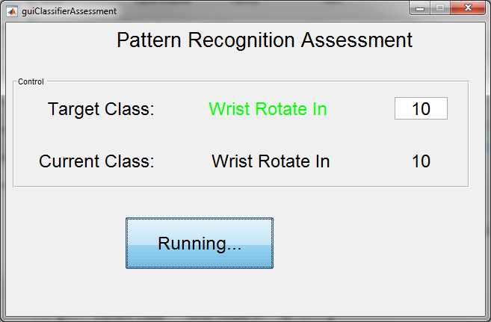
* If the use cannot complete the motion in the given time (5 seconds), then the target class turns red indicating an unsuccessful attempt.  
  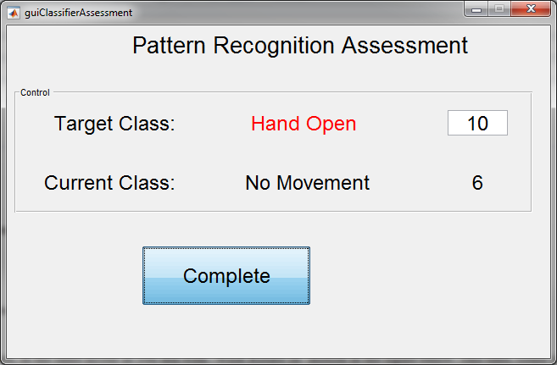
* At the end of the assessment, the user’s data should be saved. The default filename includes a prefix identifier, the date and time of the session, and a file extension indicating this as an assessment.  
  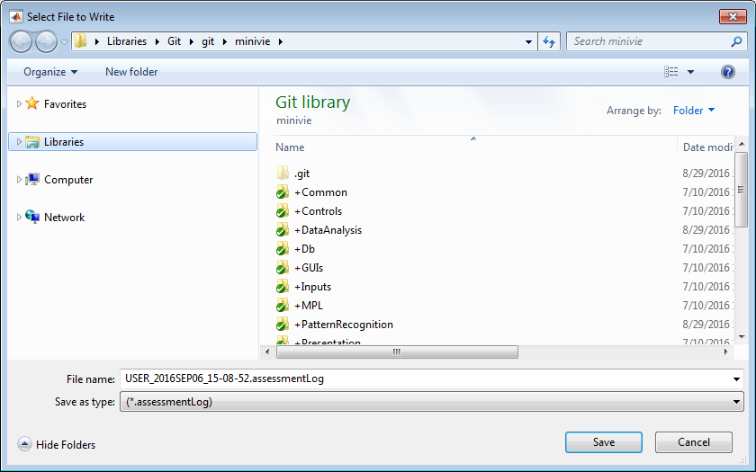
* See the Post-processing guide for information in how to analyze results

#### Target Achievement Control Test (TAC)

The TAC assessment is used to assess the ability of a user to dynamically control the joints of a prosthetic arm. From an initial arm position, the user must position the arm into an intended ‘goal’ configuration in a prescribed amount of time. There are two variants, a 1 degree of freedom test (TAC-1) and a 3 degree of freedom test (TAC-3)

* Configure and train the MiniVIE with desired motion classes
* Confirm that user is able to control the virtual limb using the Unity Visualization
* Select the ‘Assessment’ Button from the MiniVIE  
  
* Select TAC-1 from the dialog box  
  
* The user is then presented with an arm that they can control (flesh colored) as well as a goal position.

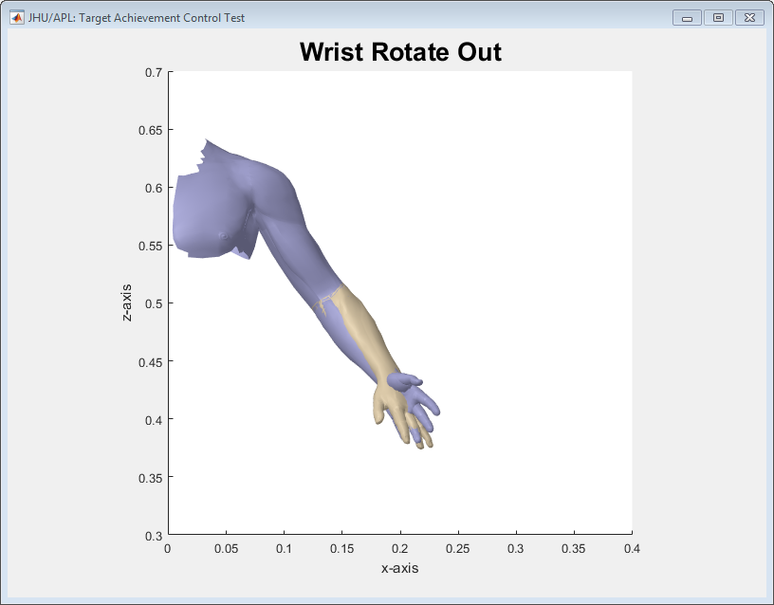

* The objective is to have the user’s arm line up with the goal arm. When the two are aligned, the target position turns green and the user must rest in this position for 3 seconds which results in a completed trial.  
  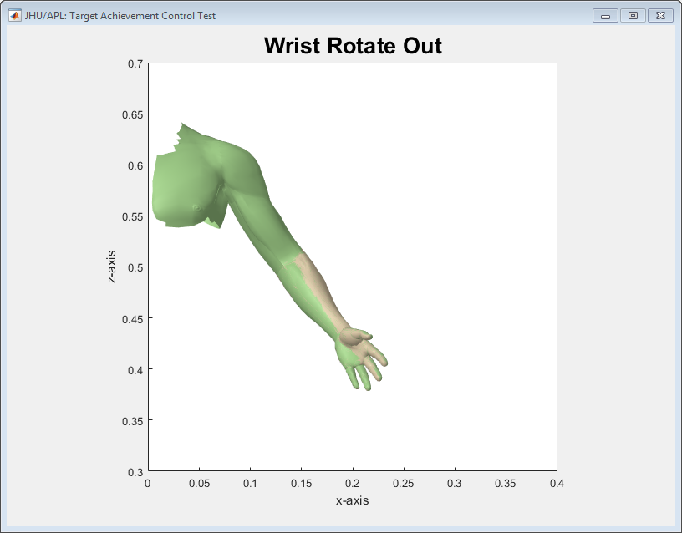
* If the user is unable to rest in the desired position (e.g. the user over shoots and can’t correct the position in time) and the timer expires, then the trial is unsuccessful.
* Each motion is presented 3 times in randomized order.
* At the end of the assessment, the user’s data should be saved. The default filename includes a prefix identifier, the date and time of the session, and a file extension indicating this as an assessment.  
    
  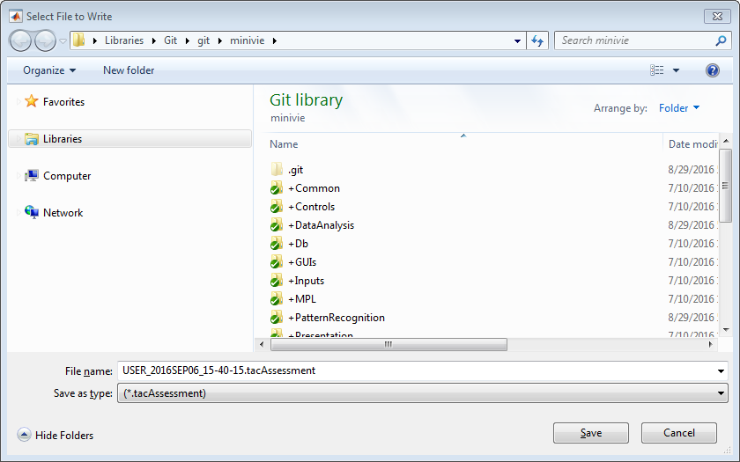
* See the Post-processing guide for information in how to analyze results

## Appendix A: Setting up Measuring Computing DAQ

Note that this DAQ must be used with MATLAB 32 bit

1. Download the [MCC DAQ CD](javascript:__doPostBack('ctl00$ctl00$m$m$lbMCCdaqCD',''))
2. Plug in USB-1208FS
3. Open InstaCal and select configure(hand on circuit board icon)

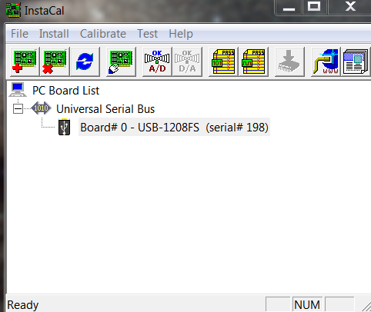

1. Under *No. of Channel*, choose *8 Single Ended*

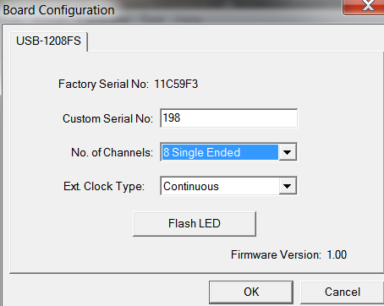

## Appendix B: Setting up Limits and Reversing Joints

This section explains how to limit the range of motion for the joints and reverse their direction of motion.

1. In the *MiniVIE Configuration Utility* window, select the *Adjust Limits* button.

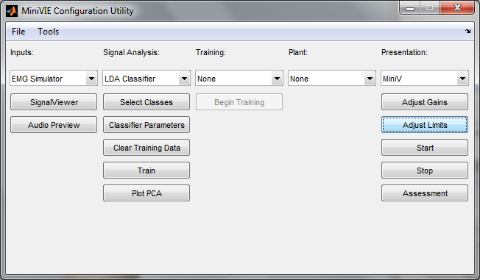

1. A new window will open showing the current angle limits for each joint

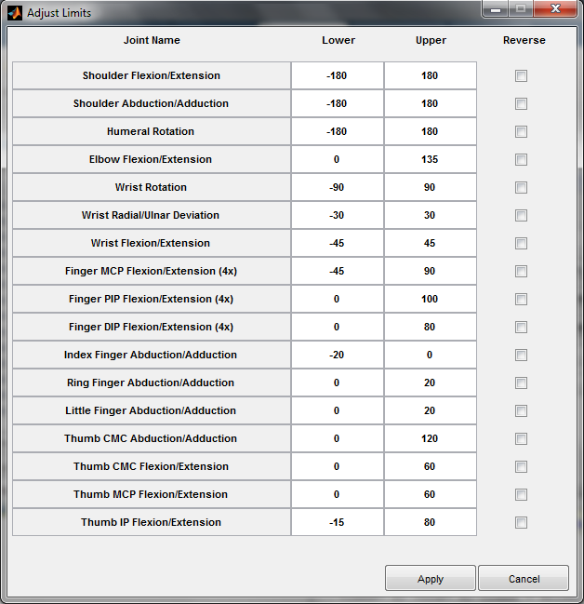

1. To change a limit, type a new number into the box.

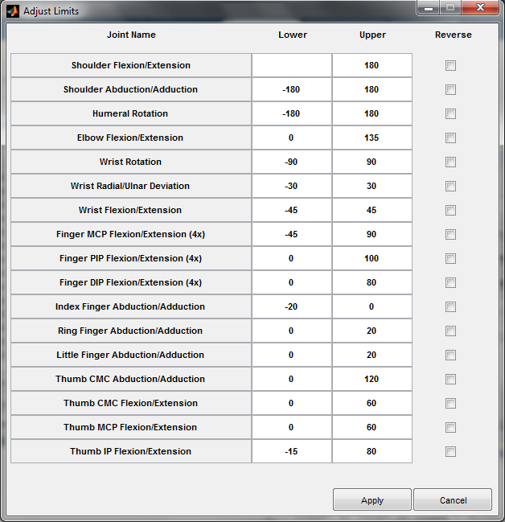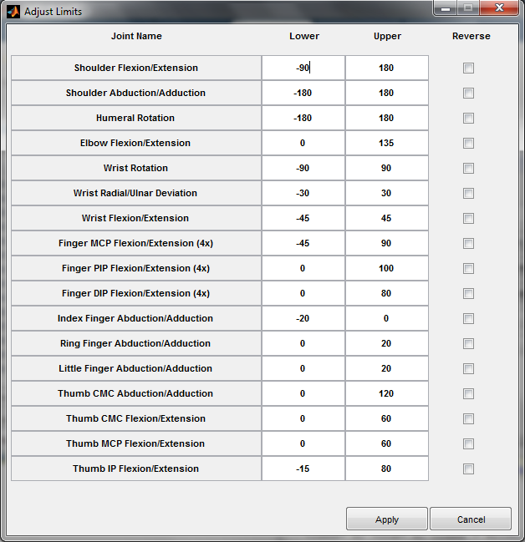

1. If a joint acts in an opposite direction as desired, it can be reversed by checking the *Reverse* box

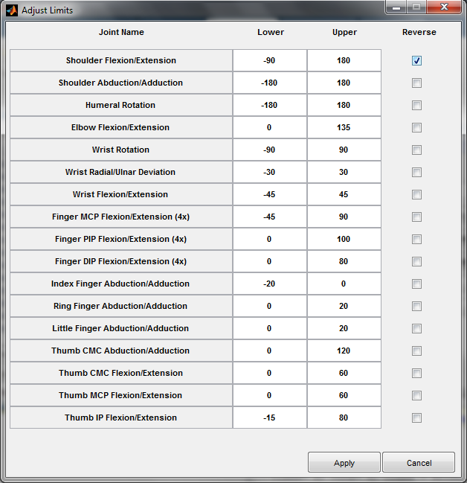

***Note:*** *reversing a joint or changing a limit will not occur until the apply button is selected*

